A D R I A T I C T A L E N T
W O R K & T R A V E L C R O A T I A

S T U D E N T P R O G R A M M E 2 0 2 6

F O R E U U N I V E R S I T Y S T U D E N T S

Work & Travel

Croatia.
A summer opportunity for students across Europe to work, connect, and experience life on the Adriatic coast, with a professional-level compensation and Erasmus+ funding.

JU N E – SE PT E MB E R 9 00 + U N I VE R SI T I E S D UBR O VNI K SPL I T HVAR ZADAR

I ST R I A N O VALJA

adriatic-talent.com
info@adriatic-talent.com
APPLY NOW →

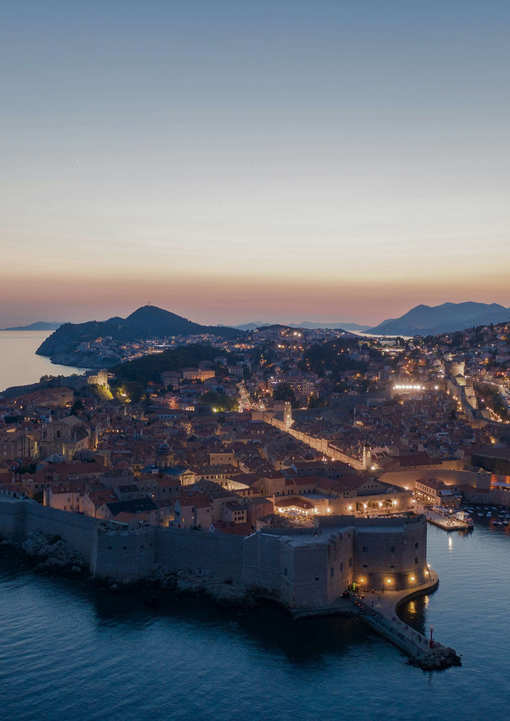
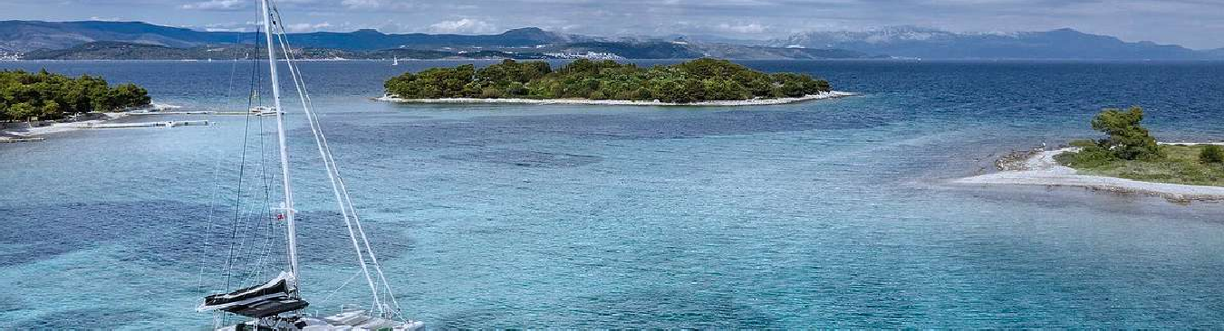


A D R I A T I C T A L E N T
Adriatic Talent j.d.o.o. ·Licensed Agencija za privremeno zapošljavanje · Zagreb, Croatia 1
A D R I A T I C T A L E N T WHY CROATI A

T H E A D R I A T I C O P P O R T U N I T Y
Europe's most stunning summer jobs.

Croatia welcomed over 21 million tourists in 2025, generating C14 billion in tourism revenue. The demand for quality hospitality workers far exceeds local supply every summer, creating the exact opportunity Adriatic Talent was built to connect you with.




21M+
Tourists visit Croatia yearly — hospitality demand has never been higher
€14B
Tourism revenue in 2024 — Croatia's single most vital economic sector
50K+
Seasonal jobs unfilled every summer — the staffing gap you can fill
1,800km
Of Adriatic coastline across Istria, Dalmatia, and thousands of islands
"A summer in Croatia is not just a job, it is the beginning of a career, a network, and a story worth telling for the rest of your life."
ADRIATIC TALENT, ZAGREB

Where can you find your dream job?
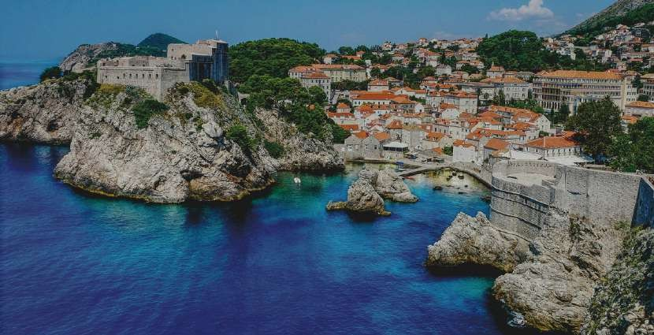
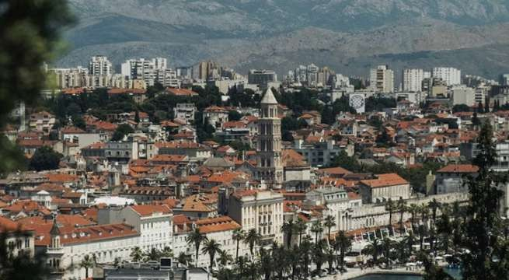
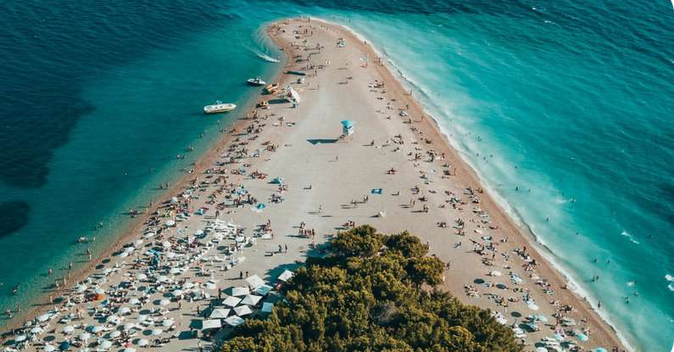
Dubrovnik
Split
Islands
Hvar · Brač · Korčula

We also place students in Zadar, Šibenik, Rovinj, Poreč, Makarska and 100+ islands. Language-matched placements mean Italian speakers go to Istria, German speakers to areas with strong German tourist flow.



p(x) ≈ F(x)

Adriatic Talent j.d.o.o. ·Licensed Agencija za privremeno zapošljavanje · Zagreb, Croatia 2

Y O U R S U M M E R P A C K A G E — E V E R Y T H I N G I N C L U D E D

Why top European students choose Adriatic Talent


C1,200+ monthly compensation
Base compensation starts at a minimum of C1,200 per month, with additional earning potential through tips — allowing total income to be significantly higher depending on role and performance.

↗ From your very first day

~C750 Erasmus+ funding on top
Eligible students receive their university traineeship grant —
paid monthly in addition to salary. We handle all documentation with your university.
↗ Up to C750/month extra

Full legal employment
Written contractbefore day one. Croatian health insurance
(HZZO) and pension (HZMO) registered in your name. 100% protected by Croatian Labour Law.
↗ Your rights fully guaranteed

Free accommodation
Housingis arrangedand provided by your employer — ready from the moment you arrive, at no cost to you. Included in every placement.
↗ Included in every placement

Friends from across Europe
Workalongsidestudents from Germany, Italy, France, Spain and beyond. Our placements build international networks — friends for life, not just a season.
↗ 10+ nationalities every season

On-ground support all season
Ourteam isreachablefrom dayoneto your last shift. Housing guidance, employer issues, document help — we handle it. You are never alone.
↗ Real people, not a chatbot
€1,200+
Monthly salary
~€750
Erasmus+ grant
Free
Accommodation

O P E N P O S I T I O N S — H O S P I T A L I T Y & T O U R I S M
Waiter / Waitress
Front Desk
Barista / Bartender
Resort Assistant
Host / Hostess
Kitchen Support
Concierge
Housekeeping
Beach Club Staff
Pool & Resort Attendant
Sales Assistant

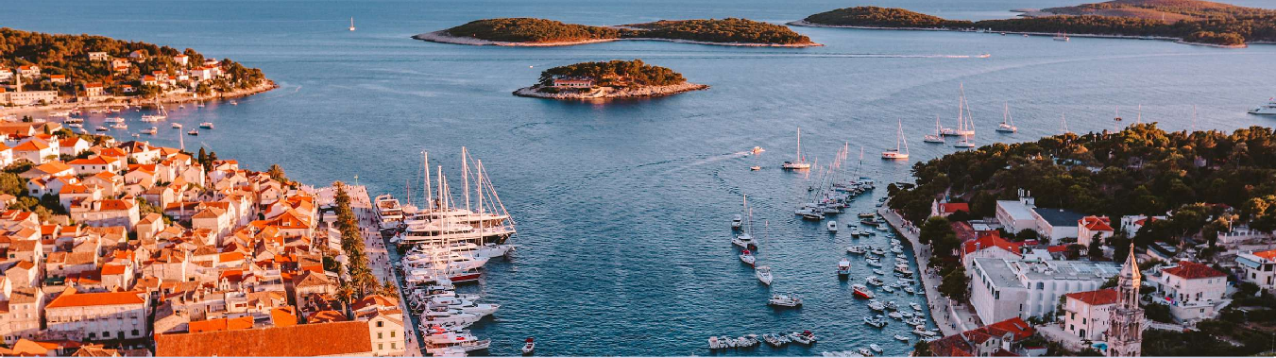
E R A S M U S + T R A I N E E S H I P P R O G R A M M E
E R ASMUS+ & HO W TO APPLY
A D R I A T I C T A L E N T
3
Adriatic Talent j.d.o.o. ·Licensed Agencija za privremeno zapošljavanje · Zagreb, Croatia
Get paid twice. Legally. Every month.


Adriatic Talent offers you path to Erasmus+ internship funds
Every placement includes a signed Erasmus+ Learning Agreement between you, your university, and Adriatic Talent. This makes your placement eligible for your university's traineeship grant, up to ~C750/month depending on your country. Paid directly by your university on top of your salary. We manage all documentation with your international office — you
just send us your university contact details.

H O W T O A P P L Y — 4 S I M P L E S T E P S



1
2
3
4
Apply online Video interview Sign contracts Arrive & earn

Short form atadriatic-talent.com — languages, availability, preferred region, CV.
20-minutecallwith our team to find the best employer match for your skills.
Employment contract + Erasmus+ Learning Agreement prepared and coordinated by us.
Showup, start work. Salary monthly. Erasmus+ grant from your university on top.

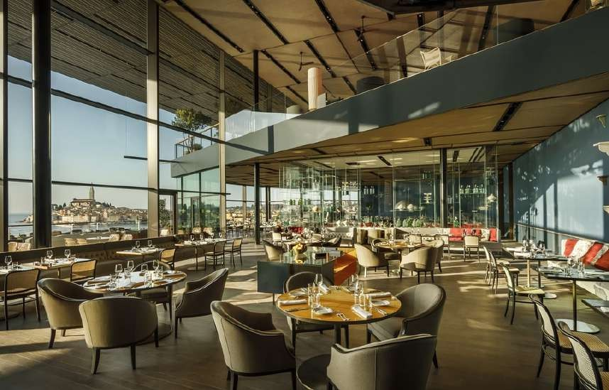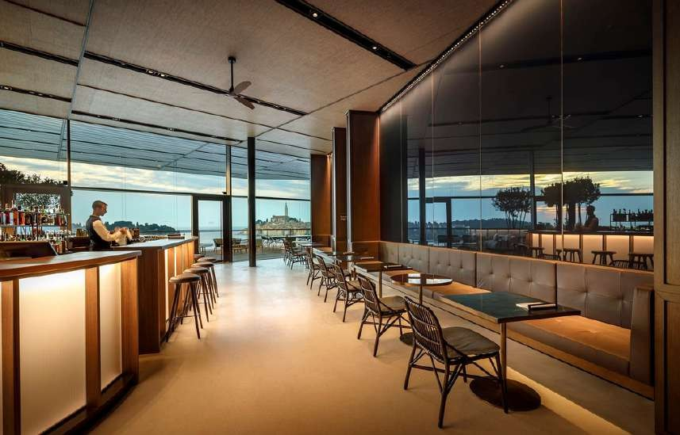

Restaurants

Hotels
Bars
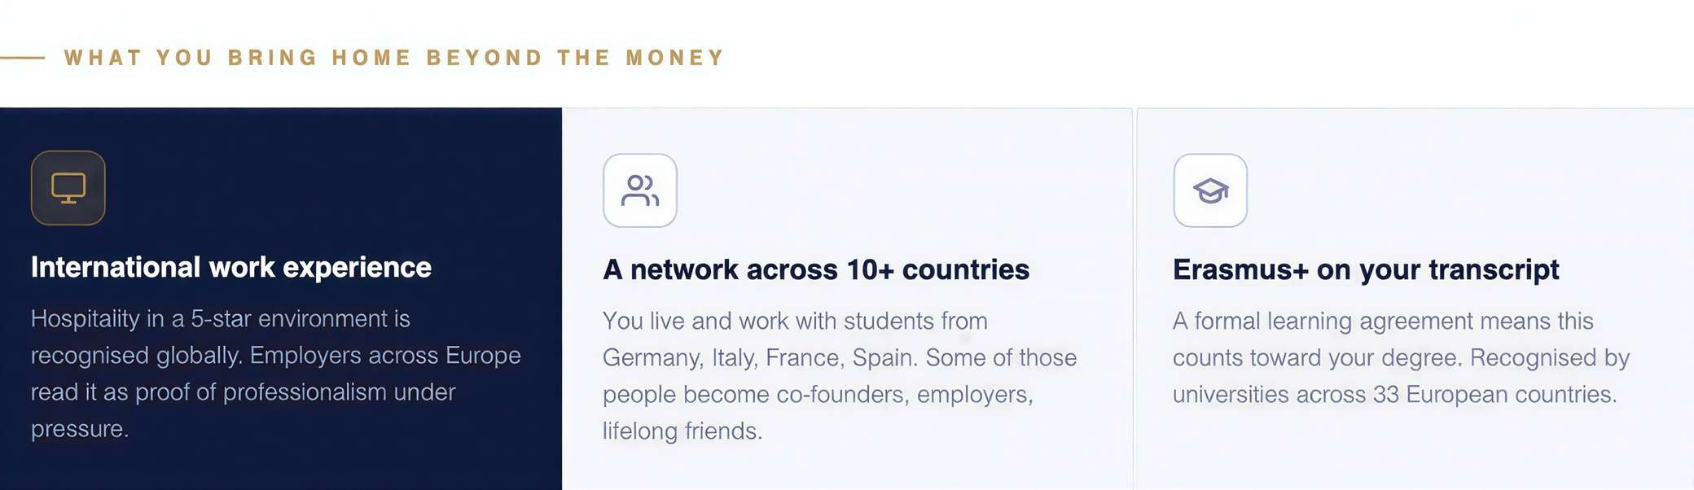
Y O U A R E E L I G I B L E I F
N O W O R K P E R M I T N E E D E D
- You are an EU/EEA university student
- EU/EEA citizens work freely in Croatia — no visa required
- Enrolled in a bachelor's or master's programme ✓ We handle all Croatian employment registration
- Available June–September 2026 ✓ Croatian HZZO covers you at work; EHIC covers travel
- Speak English, German, Italian, French or Croatian ✓ Matched to employer by language and preferred location
- Ready to work in hospitality or tourism ✓ 500+ partner universities across Europe already registered
"I earned more in three months than in a full year of part-time work at home. The Erasmus grant was a complete surprise — and accommodation was included."
Anna K.
Marketing student, Germany · Hvar, Summer 2025
"The paperwork was all done before I arrived. I just showed up, started work, and fell in love with Dubrovnik. The contacts I made changed my career."

Marco B.
Tourism student, Italy · Dubrovnik, Summer 2025


Ready to app ly?
A D R I A T I C T A L E N T
WHAT YOU GET

Apply at adriatic-talent.com, takes 10 minutes. Placements fill fast. Apply before 15 April 2026 for best destination choice.
Adriatic Talent j.d.o.o. ·Licensed Agencija za privremeno zapošljavanje · Zagreb, Croatia
4

adriatic-talent.com
info@adriatic-talent.com

