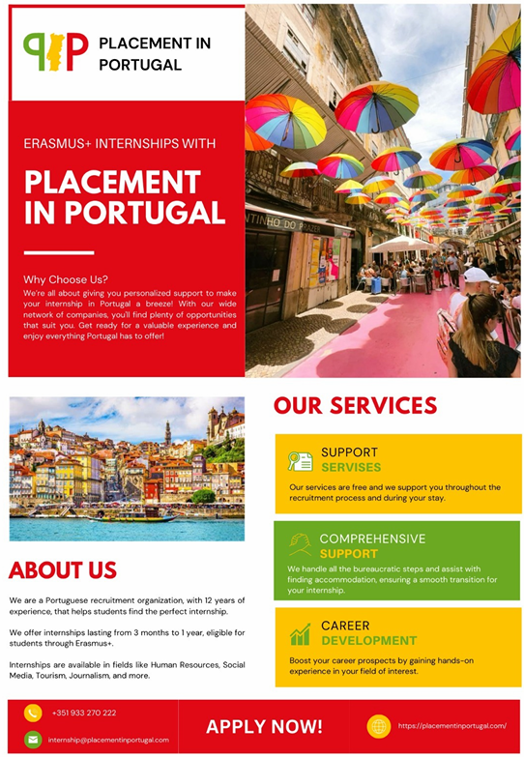

We are Placement in Portugal, an organization operating in Lisbon, since 2012, being our mission to help graduates and young professionals looking for international internships in Portugal, which matches their skills, education and preferences.
Each year, we successfully place around 400 students in internships throughout Portugal.

It's free of charge for both university and students, and you won't deal with the bureaucratic process, as we give 100% support.

We are pleased to inform you that we currently offer internship opportunities all around Portugal in many different industries for students under the Erasmus+ programme.

We would greatly appreciate it if you could share this information with your students and help identify those who may be interested in undertaking an Erasmus+ internship with us.

We handle all the necessary administrative procedures and also support students in finding suitable accommodation. A full list of available positions can be found on our website: https://placementinportugal.com/

Contact:


