Dear Colleagues,

We are pleased to invite your institution to participate in two parallel Blended Intensive Programmes (BIPs) organized by the International Business School (IBS), Sofia, Bulgaria, taking place in April–May 2026.
Both programmes follow the Erasmus+ BIP format and combine a virtual preparatory phase and a physical on-site component in Sofia. We warmly invite your students and academic staff members (STA participants acting as mentors) to take part in this international project-based learning experience.
We kindly ask for your support in disseminating this call among your students and interested academic colleagues.
This year’s programmes focus on entrepreneurship, innovation and applied project development and offer participants the opportunity to work in international teams, receive academic mentoring and participate in a final pitch competition with awards.
Participants can apply for one of the following BIP tracks:
2) Summer School on Entrepreneurship and Innovation
Digital Cultural Heritage Innovation Lab: From Content to Market Impact
Focused on digitalization of cultural heritage, tourism innovation and creative digital project development.
Programme dates:
Virtual component: 20 April 2026
Physical component in Sofia: 27 April – 1 May 2026
 Application link for participants: https://forms.gle/HjAThjJmrdFhTtrf7
Additional information about both programmes is also available on the Erasmus BIP platform:
https://erasmusbip.org/list-of-bips/
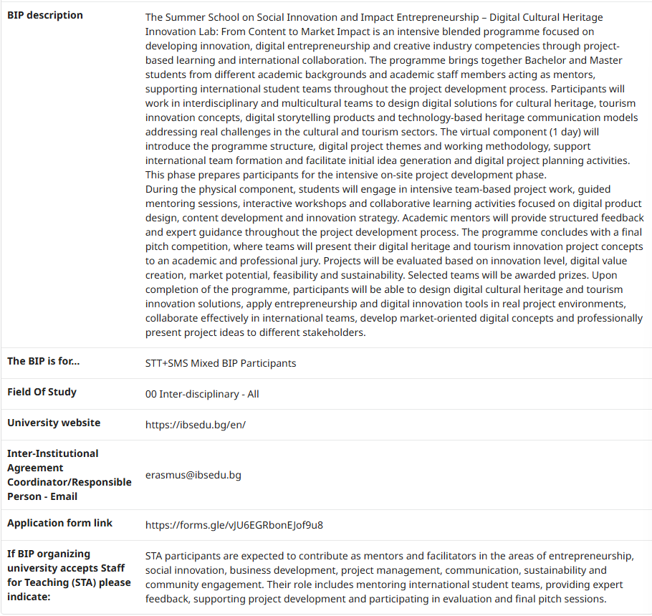
After the application phase, selected participants will be contacted and the official nomination process will be coordinated with your Erasmus+/ International Relations Office.
We look forward to welcoming students and academic staff from your institution in Sofia.

